One Small Town INFINITY Tokens
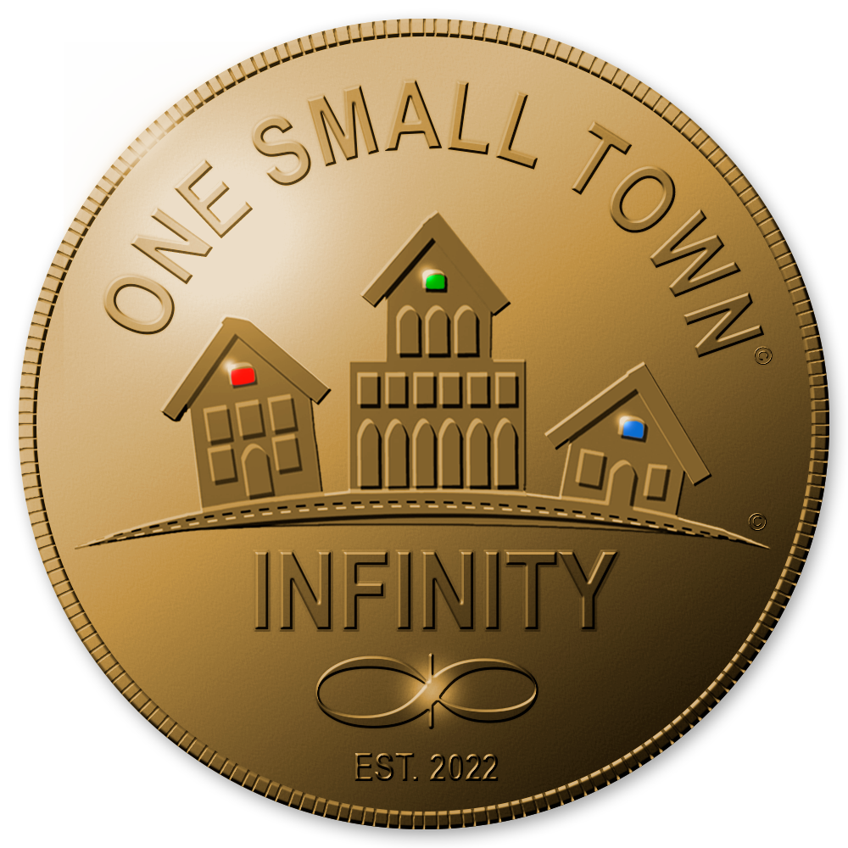
INFINITY Tokens, a part of the One Small Town proposal, are used for trading goods and services by One Small Town members and customers.
The tokens are used as proof of time contributed by members with one token for every 3-hour shift. The tokens can be exchanged for a food & goods basket every month. Members can earn additional income by contributing more time and can send tokens to any other member in the system with a digital wallet.

Foundations and video explanation
The proposal was founded by Michael Tellinger, founder of the Ubuntu Party and the Ubuntu Liberation Movement.
To learn more about the proposal, a video explainer has been provided by Michael here.

Links
Website: https://www.onesmalltown.org/tokens
OST member login: https://ost-platform.com
Facebook: https://www.facebook.com/michaeltellinger
Twitter: https://twitter.com/MichaelTelling2
YouTube: https://www.youtube.com/c/Michaeltellinger

