Introduction to Numero Set

Originally created by Jason Nelson in 2009, Numero Set is a transaction management system based on the principles of Equal Distribution Economics and features a points system called Numero.
For an introductory video to Numero Set, go here.
For more videos, check out the Numero Set channel on YouTube.
Numero Set and additional media can also be found on Facebook here, and on Twitter here.

How it works

Points can be sent from member to member to account for your transactions instead of using money, and new issuance rates are set after the membership count reaches a Fibonacci number.
Like the new rates, new issuances are also tied to when the membership count hits a Fibonacci number, but a new issuance may occur at any time.
When an issuance occurs, every member gets an equal amount of Numero from the system's issuance account which takes on the debt of the issuance and is never owed back to the issuer whether in the form of a debt or a tax.
New members also receive their own issuance in the form of a balancing issuance upon signup. A balancing issuance for new members is based on the last issuance rate set.
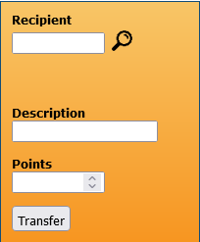
Once you log in, if you want to demo the system fill out the yellow transfer form using the following information. Later the Numero you transfer will be transferred back to you:
Recipient: Operations
Description: Demo
Points: 1
To send points to another member, simply type in their account number in the Recipient field, a description for the transaction, and how many points you want to send. Hit transfer and the transaction will reflect on yours and the recipient's ledger.
If you cannot recall an account number, you can use the magnifying glass near the Recipient field to enter an account number of a member you've stored in your contacts. From the list of contacts that appears, simply select the contact name and their account number will appear in the Recipient field.
Members can value products and services in whatever way they want, but the standard reference is 1 Numero = 1 tomato (accounting for a product given) and 20 Numero = 1 hour (accounting for your time or service given).
Numero Set is a formal transaction process with a production focus. You can learn more about this process type here.

The benefits
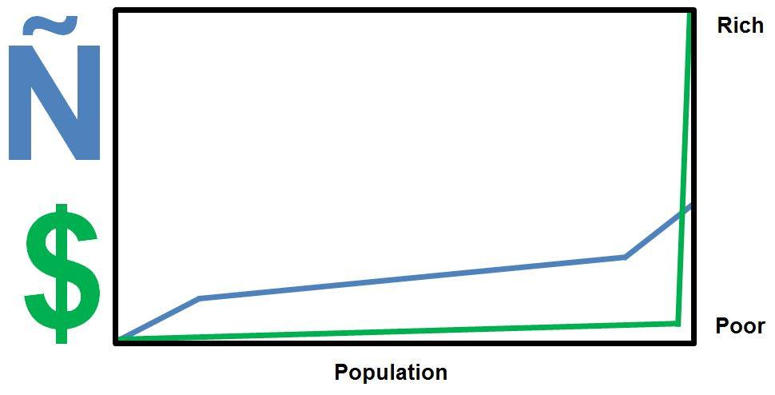
Proponents of Numero Set believe its system if brought to scale creates a more narrow difference between the rich and the lower class. That the distribution of the currency (or points) being issued equally rather than selectively grants the lower class more potential to participate in its economy, creating more economic freedom and less poverty.
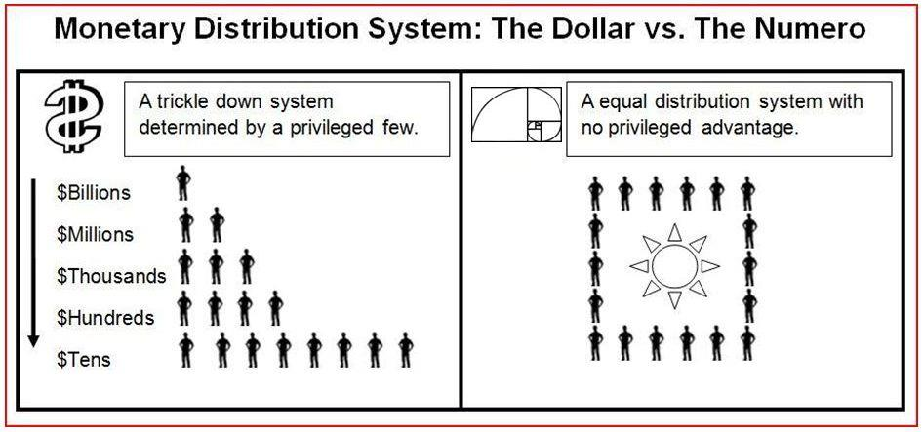
Numero Set proponents believe that an equal issuance distribution creates no privileged economic advantage. Where even if a small number of Numero Set participants somehow ended up with most of the Numero that was issued into circulation, subsequent equal issuances will simply begin to rebalance and even out the economic playing field.

Advocates for the system propose that Numero Set is the optimum (or ideal) tool for time and resource management, and for guarding against abuse of time and resources. And that if no form of accounting is used to facilitate a transaction, growth of your group or organisation is either not possible, or becomes significantly reduced.

Philosophy and the case for its use
Numero Set claims its system has no say over the culture that is created that uses or takes part in its system. That each individual should have autonomy in how they transact with others. Thus the issuance being equal rather than selective it claims permits this for each individual.
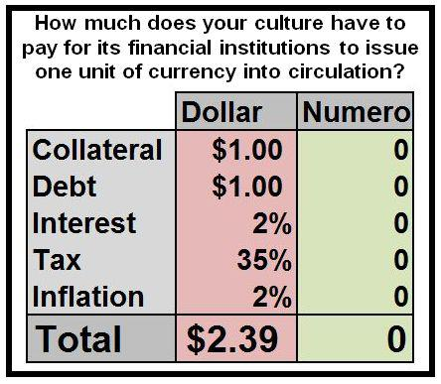
Numero Set believes the issuances should be free and not charged for their use with no hierarchy system issuances should be filtered through before they are issued and accessed, and never should be owed back to the issuer for any reason.
Dependencies on money Numero Set believes occur when systems like its own are not used, often leading to organisations forming dependencies on donations to manage and maintain themselves.
Thus individuals remain unable to grow their organisations because of the cost factor of only using money for their transaction management. That if Numero Set was either used alongside money or instead of money in a given transaction, the monetary costs can now be lowered saving money and decreasing dependencies on only one system.

Feature set highlights

- Ability to send points from member to member
- Ledger with transaction date, participating accounts, description, transfer amount, and balance
- Editable contacts list for making quick transactions to stored members
- Transparent transaction quantity and current total Numero amount in circulation across the system
- Accessible from any device

Signing up
Registration to Numero Set requires manual approval. After approval you will be contacted with sign-in instructions and a balancing issuance of Numero will be issued to your Numero Set account to begin transacting.
You can go here to sign up.

Summary
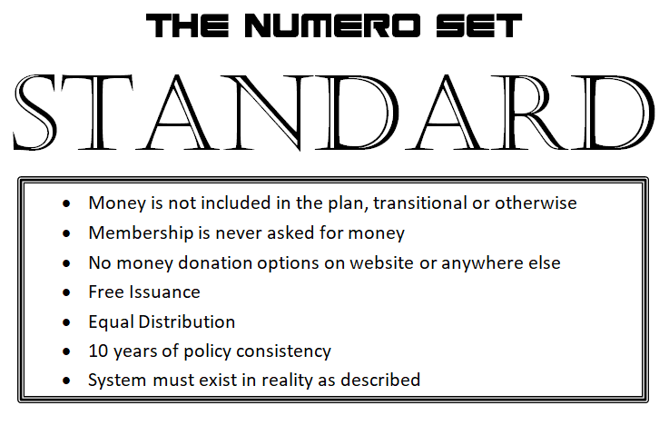

Links
Website: https://numeroset.net
Facebook: https://www.facebook.com/NumeroSet
Twitter: https://twitter.com/NumeroSet
YouTube: https://www.youtube.com/c/NumeroSystem

Powered by ezWeb.ie

