A Transition-Oriented Enterprise1) is a type of business which provides some useful service to the community while excess profits are used for wider benefit rather than just enriching individuals.
The proposed plan is to create a group of Transition Enterprises which brings some useful services or goods to local markets (or global market if it's the case of thinking of selling goods across the countries) while the a portion of the profits will be used to invest in the creation of other TE's, acquiring and liberating some goods globally for free, investing in social support programs or supporting economically full-time activists.
TE's also can act as co-ops businesses managed by its active members, democratizing the decision-making process and decentralizing the power.
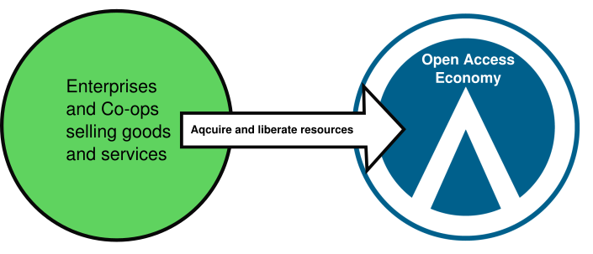

1)For more information on Transition-Oriented Enterprises follow this link.

